Documentation Project 2.2 United Emirates Group

Members:

Martijn Hofstra: 406688
Jan Udema: 372644
Milan Schuringa: 359838
Lieuwe Baron: 403432
Stijn Prins: 405151
Martijn Boer: 406271

The requirements from the client are:

- The website needs to have a simple login system (username/password).
- Data needs to be encrypted (https).
- Use the colours of the United Emirates.

- The data on the website should be downloadable in XML format.

Data requirements:

- All weather data of stations in Asia with minimum temperatures below 0 degrees Celsius.
- Top 10 of stations with lowest temp in Asia.
- The website should still function with a relatively poor internet connection.

The design of the distribution application with an explanation:

- We installed Ubuntu Desktop 20.04 on the VM C, we chose Ubuntu Desktop 20.04 because: it is free, flexible, smooth performance in testing.

- Debian 10.6.0 on the VM B, we chose Debian 10.6.0 because: We have chosen Debian OS because: It was lightweight and because you can very specifically chose what to and what not to install, but in hindsight this was not a good choice because a lot of features that we needed were not installed and we lost a lot of time figuring out how to install those.

Which JVM-implementation did you choose for the
VM B?
- We choose the JVM Hotspot because it came installed with our Open-JDK installation (version: 15.0.2).

How do you transport the data on the VM B to the VM C?
- On the VM C there is a Java server which listens for requests on port 5000.

Which Scripts and configuration changes in the OS and/or JVM have you implemented?
- A proxy has been placed on all the VM’s.
- The website is being hosted by NGRock.

General information:
- The data is imported by Java in CSV and put into a folder.
- The website converts the CSV to an XML file and puts the data in an array to display the data on the website.
- The site based on HTML with CSS and php, the website is HTTPS. The colours from the sites are based on flag from the United Arabic Emirates. The php code converts the XML files into arrays and sorts it to temperature.
- Each new connection is assigned a thread out of the threadpool that has been realised before the connections have connected, its size is 1000.
- We do not use synchronisation in Java.

Code:
- The code is explained in comments in the code files.

Stress report:
- Our program is easily capable of meeting the performance requirements, as you can see in the picture, running 800 clusters at a time is not a problem at all.

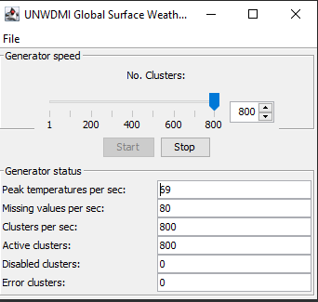

GitHub:
- https://github.com/milano1110/Project_2.2-Weather-Application

